*Extension of the application deadline for the Summer School “Recent developments on financial crime, corruption and money laundering: European and international perspectives” (Thessaloniki, 4-12 July 2018)*
Sign up until June 15th 2018 in order not to miss out!

Summer School
“Recent developments on financial crime, corruption and money laundering: European and international perspectives”
Thessaloniki, 4-12 July 2018

The Research Institute for Transparency, Corruption and Financial Crime, Faculty of Law - Aristotle University of Thessaloniki (http://anti-corruption.law.auth.gr/), hosts an intensive 8-day summer school on recent developments in the fields of financial crime, corruption and money laundering at a national, European and international level, for participants who wish to advance their knowledge in this field.
The summer school will focus on ongoing developments of key issues in combating international fraud, corruption and money laundering, international and European anti-fraud mechanisms and procedures, etc. Recent developments to be discussed will include, inter alia, the new directive on fraud against the EU financial interests, the new Regulation on the European Public Prosecutor’s Office, the 4th anti-money laundering directive, which recently came into force, as well as the proposal to amend it, etc.
For more details and applications you could follow the link: http://anti-corruption.law.auth.gr/en/anti-corruption/7182
The application deadline is 15 June 2018.
We look forward to meeting you!
--
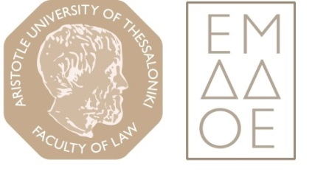
Research Institute for Transparency, Corruption and Financial Crime
Faculty of Law
Aristotle University of Thessaloniki
University Campus
54124 Thessaloniki
Greece
e-mail: anti-corruption@law.auth.gr
http://anti-corruption.law.auth.gr

